Euromediterranea 2004  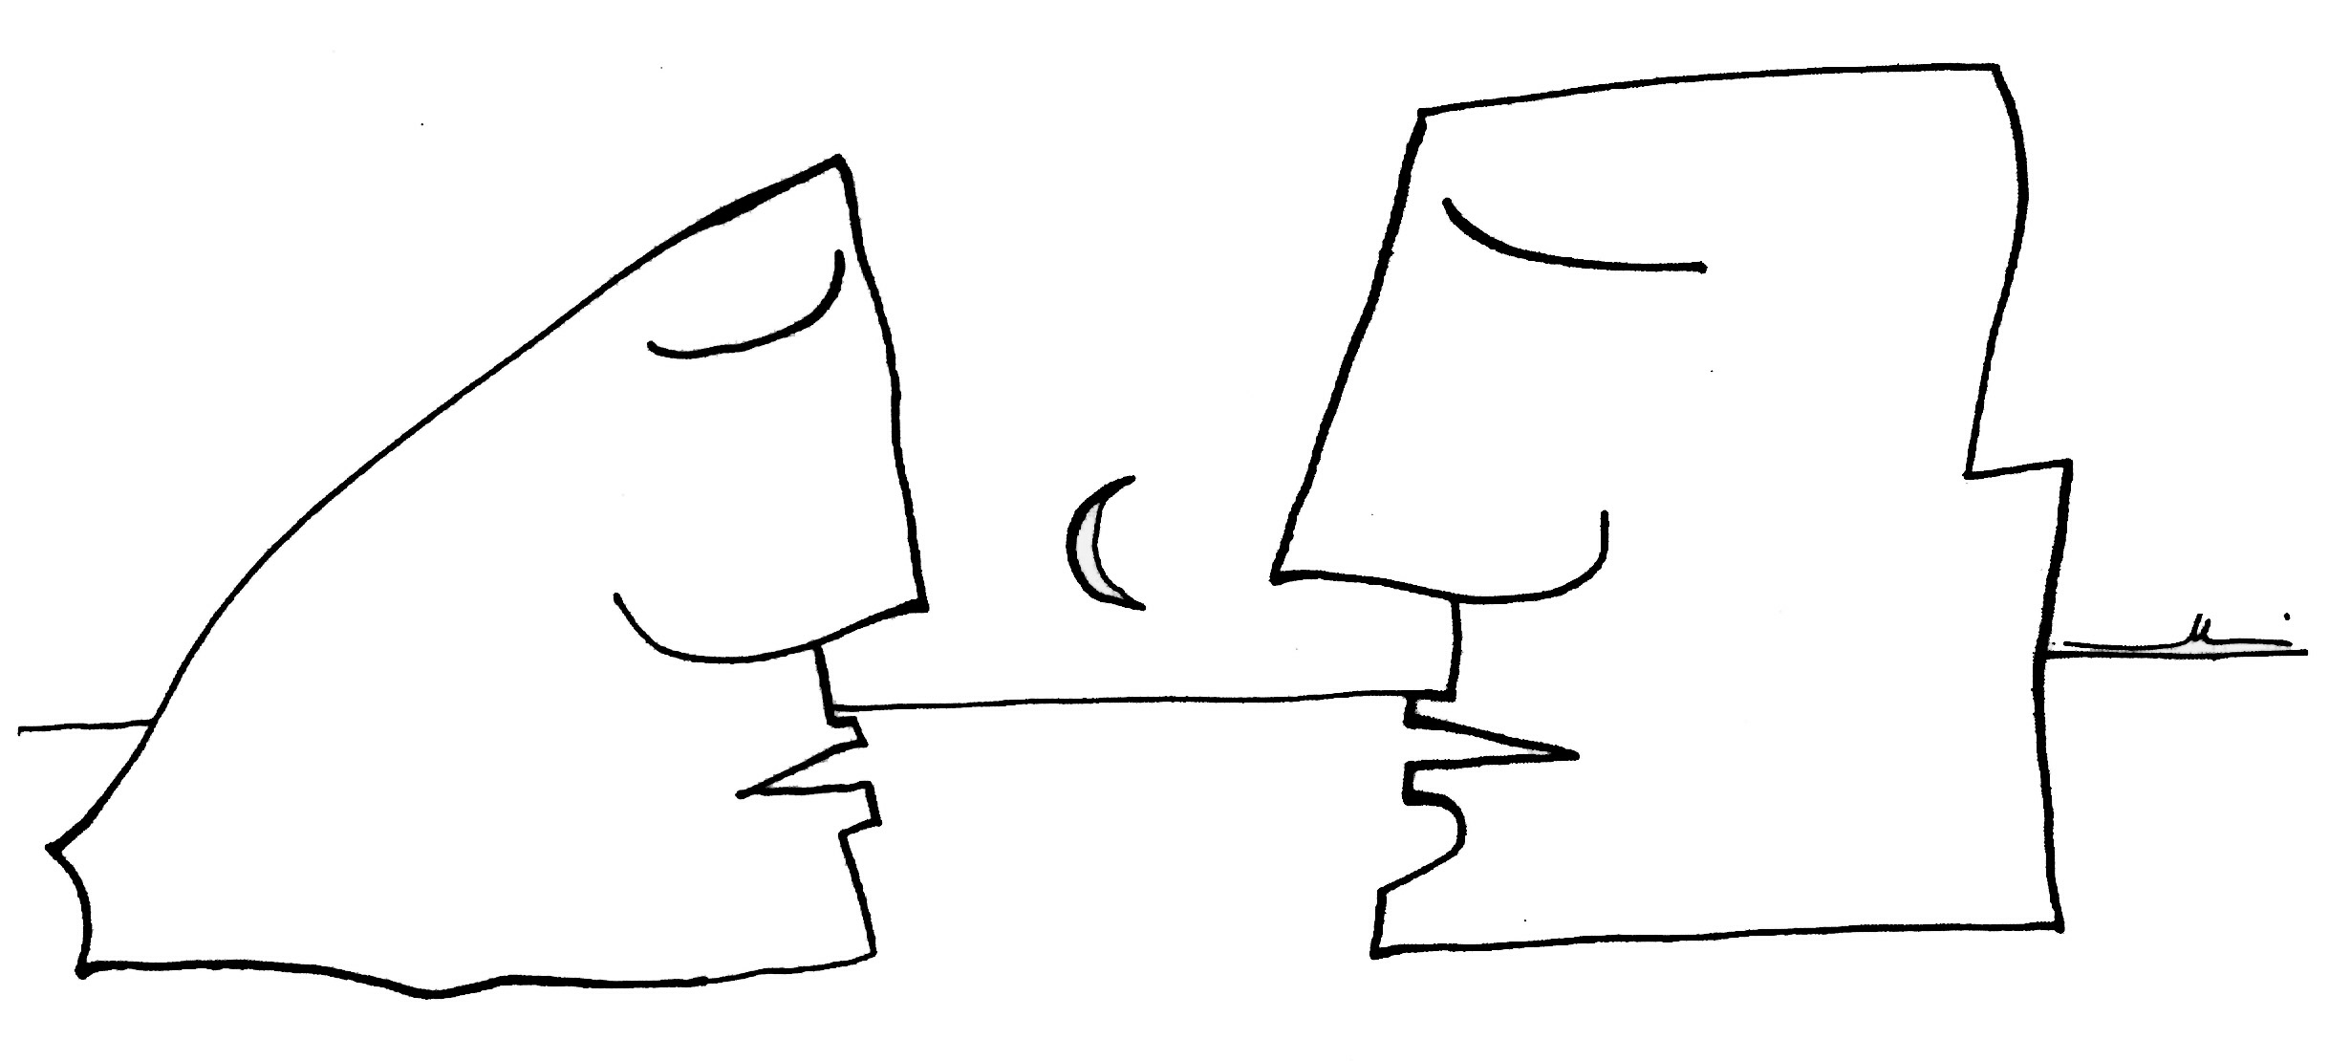  INSTANT REPORT:  Open Space Technology  Europe as we want it  How can we draw on diversity to build a richer Europe?  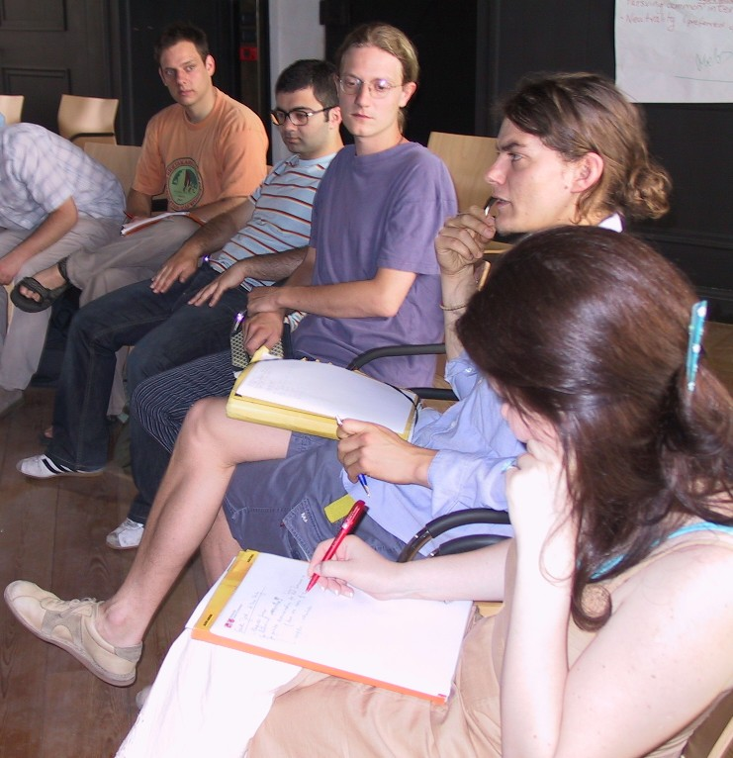  Bolzano/Bozen  2 July/luglio/Juli 2004  Sala del Municipio Vecchio/Altes Rathaus  Via Portici 30 Lauben  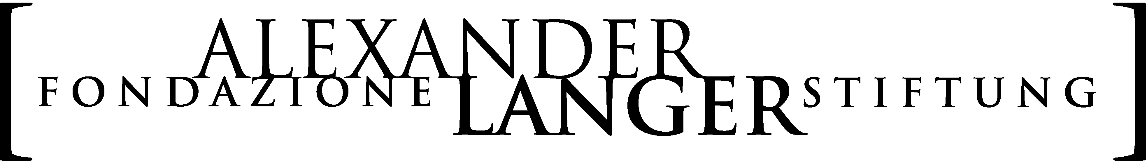 |  | International Summer School  “You know a country through the way it treats its minorities and you know a minority through the way it treats persons.”  Jacek Kuroń  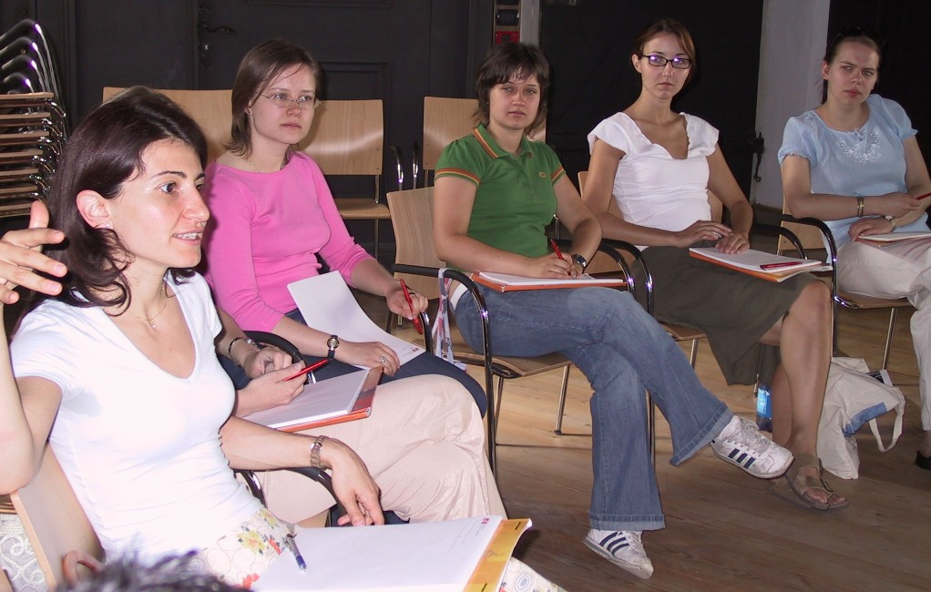  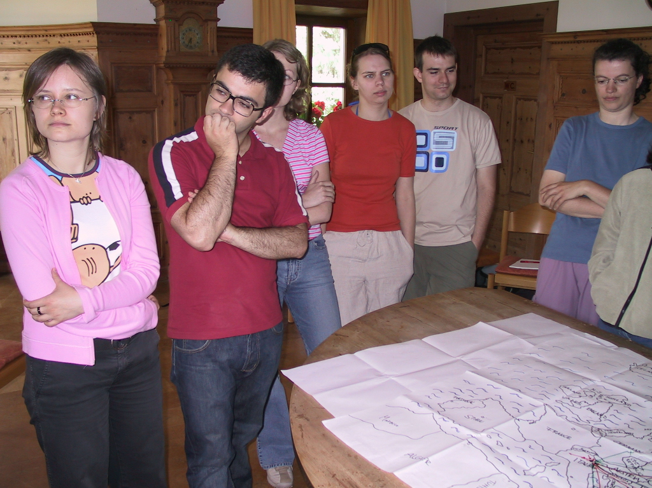
Who proposed the topic  Urszula Kowalska  Who participated in the group  Marton Konya  Katarzyna Dudek  Matthias Renter  Stefano Boninsegna  Sara Carneri  Vincenzo Pietrogiovanni  Gabriela Kowalska  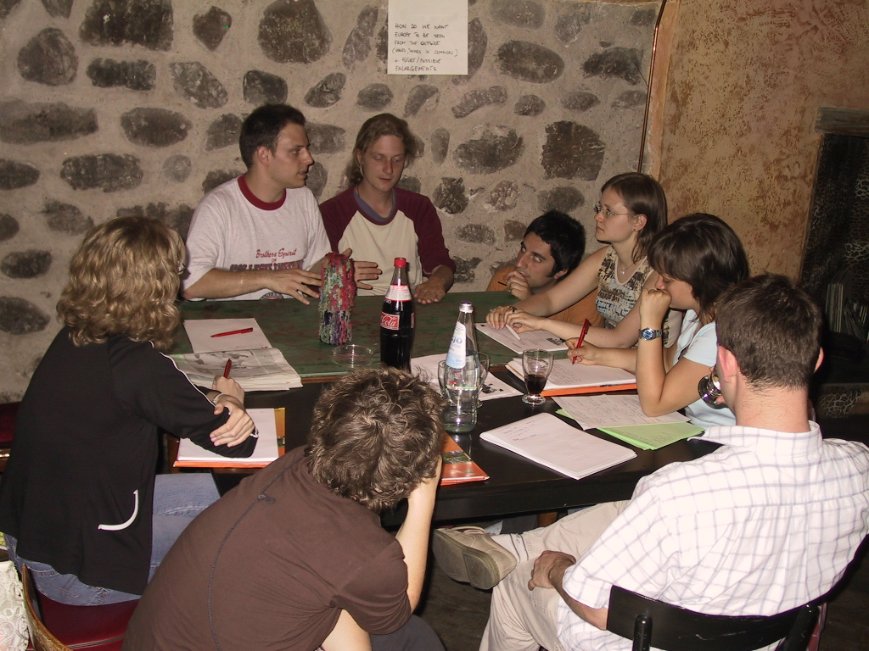 | DEFINING THE EUROPEAN UNION FROM INSIDE AND OUTSIDE  Outcomes of the discussion  OUR MAIN FINDING:  It is difficult to say what the idea of the EU comprises, as there are many possible perceptions of it. But if the EU wants to function well and project itself as one strong voice at global level, definitions can bring a better understanding.  OUR PERCEPTION IS THAT  In a first instance the EU was created to prevent the outbreak of conflicts between the founding countries. Then it developed towards guaranteeing favourable conditions for economic growth. At the moment, the EU is a reality that includes religious identities, ideology, certain basic shared values and general democratic principles, and operates at the level of economy, politics, social policies.  The issue of minorities is a very important one. We think we should foster both the aspects that we have in common and the peculiar characteristics of each region. The uniqueness of each member of a community enriches the quality of living together. Therefore, in balancing between shared values and diversity, we want to work on a policy of integration rather than assimilation.  One of the aims is mutual help between the EU members. We believe that this requires taking the time to learn to listen to each other and live together, to respect each other’s strengths and weaknesses. As a first immediate step we see the need to work towards a European Constitution which would respect and empower diversities and minorities on local level in a framework of European common rights.  The EU is an association of people who share also a supranational identity. Therefore, we believe, the concept of EU can go beyond geographical borders of Europe.
Who proposed the topic  Lia Potec  Who participated in the group  Gaetano Ranieri  Urszula Kowalska  Stefano Boninsegna  Sonja Cimadom  Sara Carneri  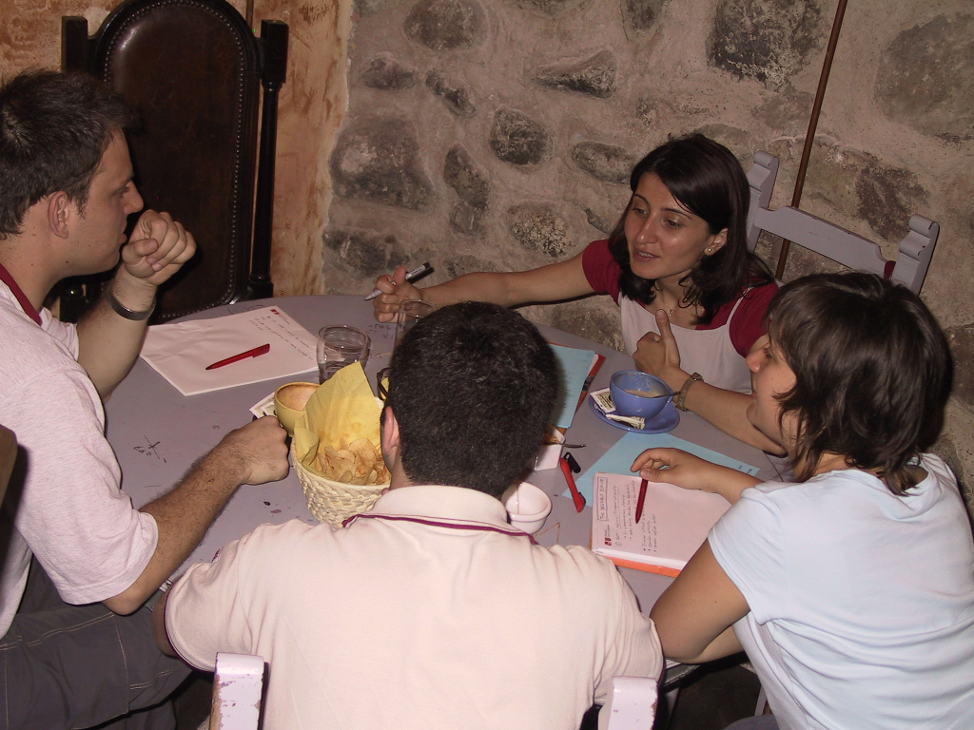 | ENHANCING EUROPEAN CITIZENSHIP  Outcomes of the discussion  The starting point of our discussion was the different treatment that some of us experienced after showing a certain national passport. We believe that this was due to the labels we still get attached because of our national citizenship.  WHAT WE WANT  - A Europe of multiple rather than national identities  - A grass-root Europe  - Compatible welfare systems based on minimum common standards  - Flexible and compatible educational systems  WHAT WE ALREADY HAVE OR IS UNDER CONSTRUCTION  - When traveling abroad, European citizens are granted protection by any of the other EU member states’ embassies  - EU citizens have the right to vote anywhere in Europe in local and European elections  - EU citizens may benefit from basic social services when traveling or residing within the EU  - European info points  - European-wide recognition of university diploma; educational, vocational and youth exchange programs (e.g. Socrates, Leonardo, Youth for Europe)  WHAT WE PROPOSE  - European passport with EU symbol on the front cover and “European Union” printed in all EU languages, to replace the national ones  - European Ombudsmen in every municipality as a warranty that each person is respected and listened to by public institutions  - More and more substantial internships (short term work contracts) in institutional structures  - European Clubs encouraging meetings of the roaming Europeans and local ones to promote better mutual understanding  - Europe-wide recognition of high-school diplomas and a transparent and accessible system of university admission  - A network of European summer schools and host-families to promote language and culture learning for children from an early age on
Who proposed the topic  Gaetano Ranieri  Who participated in the group  Matteo Faiffer  Vincenzo Pietrogiovanni  Gabriella Szabo  Lia Potec  Elisa Salvadori  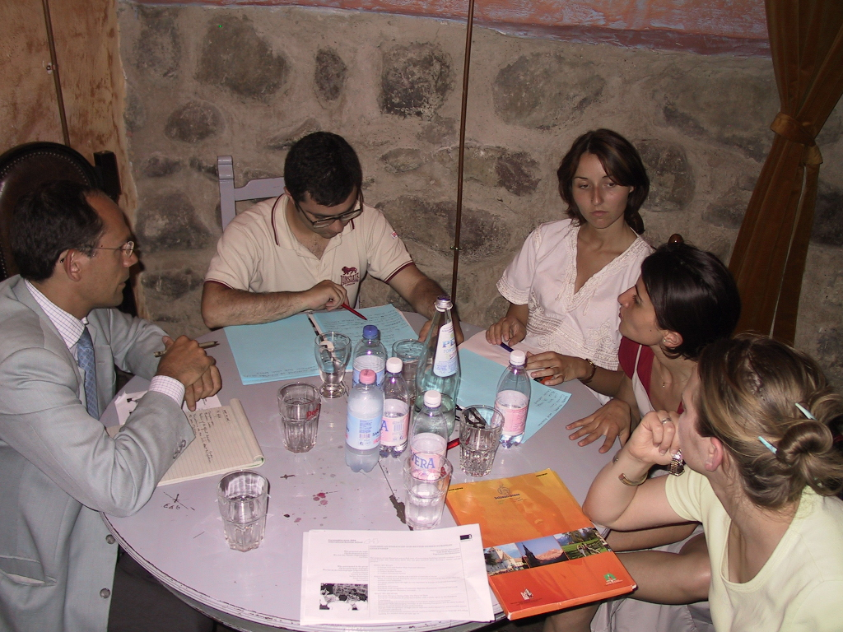 | DEMOCRATISING DEMOCRACY  Enhancing the participation of citizens in the decision-making process  Outcomes of the discussion  The theme of our discussion was how to bring EU politics and the idea Europe closer to the European citizens.  OUR MAIN FINDING:  - To reduce “democratic deficit” at European level it is necessary to improve active citizenship at local level (e.g. Brazilian experience of “Orçamento Partecipativo”, a form of participatory budget management)  WAYS TO ACHIEVE IT:  - Better coverage of European issues in national and local media  - Discussion groups at grass-root level concerning the contents of the European Constitution  - Starting from this experience, develop local fora for debating issues of pan-European concern (e.g. environment, renewable energy, foreign policy, welfare systems)  - Referenda at European level on issues that directly concern the European citizens (based on a Europe-wide quota system, i.e. vote as a European rather than as an Italian, Hungarian, Polish, German…)  - More power to the European Parliament and more active engagement of the European MPs with their local constituency (e.g. monthly open meetings)  - EU as a study subject in schools  - Promotion of pan-European projects initiated and developed by high-school students.
Who proposed the topic  Gabriela Kowalska  Who participated in the group  Andrzej Paczkowski  Konstanty Gebert  Gabriella Szabo  Katarzyna Dudek  Elisa Salvadori  Sonja Cimadom  Sebastian Illing  Matthias Renter  Urszula Kowalska  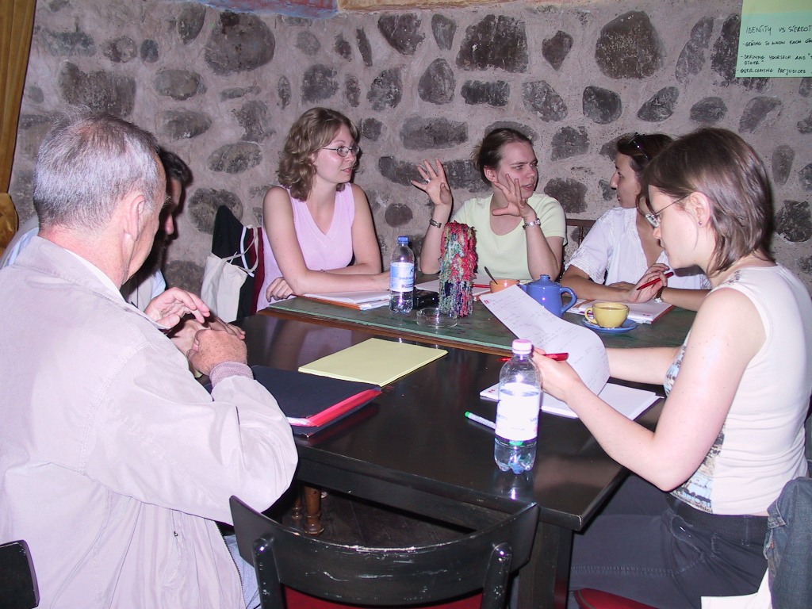 | IDENTITIES vs. STEREOTYPES  Outcomes of the discussion  OUR MAIN FINDINGS:  - Stereotypes and identities are interconnected.  - Stereotypes are part of how we react to the world and they fulfil a function, so they cannot be eliminated, but they can be changed.  - Identity is what we feel about ourselves, which is related to how we deal with differences between “us” and the “others”.  - Our identity is made of many complex labels and it may evolve in time.  - Stereotypes work as first generalised knowledge of the others.  - National stereotypes affect how Europeans perceive each other.  - We need to learn how to challenge stereotypes  WHAT WE CAN DO:  - Enhance self-esteem as a way of resisting being victims or perpetrators of negative stereotypes  - Work on a balanced self-esteem so that we don’t need to oppose and attack the others in order to know who we are.  - Rely on personal experience and knowledge to challenge stereotypes.  - Multiply the sources of information when building portraits of ourselves and the others  - Draw on positive examples such as ARTE, the Franco-German cultural channel about Europe, and expand it on European level.  - Strengthen and spread mobility programmes such as Socrates and Leonardo.  - Share our intercultural experiences with our fellow citizens to work on stereotypes from the inside.  - Be sensitive about all kinds of stereotypes in the society not just the personal or national ones.
Who proposed the topic  Vincenzo Pietrogiovanni  Who participated in the group  Emilia Mohan  Marton Konya  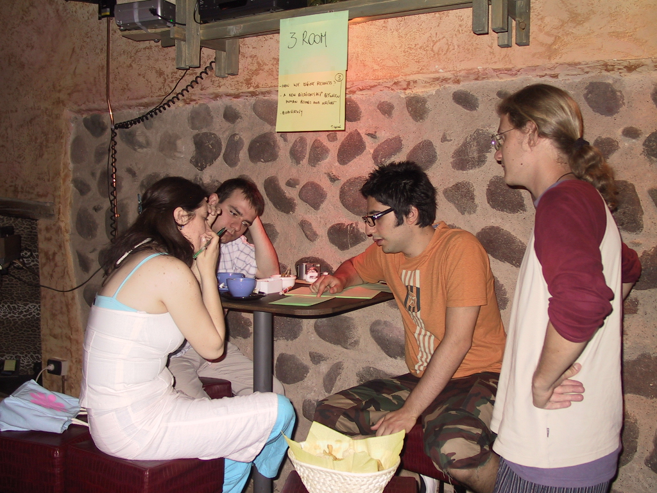 | HOW DO WE DEFINE “RICHNESS”?  A new relationship not only among human beings but also between humankind and nature  Outcomes of the discussion  Let the next generations have the same chances to exploit natural resources and enjoy the richness of biodiversity as we do.  WHAT WE WANT:  - Environmental sustainability  - Diversity in culture  - Responsible European Citizens  - Europe as a force that promotes networks that support sustainable ecological alternatives to destructive economy, catastrophes, desertification and consequent war situations  HOW WE CAN ACHIEVE IT:  - Make people more conscious about risks  - Promote tolerance and eco-sensitivity  - Reevaluate old traditions and customs  - Give more importance to individual behaviour, civic participation, confrontation, attitudes, and critical information to build a collective of responsible European citizens  - Elevate participation into a means of involvement in society through education, knowledge and technology  - Develop a critical attitude towards consuming habits and lifestyle  OUR FINAL STATEMENT:  Europe has a debt, an ecological debt, to pay back to the other continents.  We are not rich but we are enriched; they are not poor but impoverished  Richness is not enrichment and poverty is not impoverishment.

